**Creating Microservices for account and loan**

**Account Microservice:**

* **AccountController.java:**

package com.cognizant.account.controller;

import com.cognizant.account.model.Account;

import com.cognizant.account.service.AccountService;

import org.springframework.beans.factory.annotation.Autowired;

import org.springframework.web.bind.annotation.GetMapping;

import org.springframework.web.bind.annotation.PathVariable;

import org.springframework.web.bind.annotation.RequestMapping;

import org.springframework.web.bind.annotation.RestController;

@RestController

@RequestMapping("/accounts")

public class AccountController {

@Autowired

private AccountService accountService;

@GetMapping("/{number}")

public Account getAccountByNumber(@PathVariable("number") String accountNumber){

return accountService.getAccountByNumber(accountNumber);

}

}

* **AccountService.java:**

package com.cognizant.account.service;

import com.cognizant.account.model.Account;

import org.springframework.stereotype.Service;

@Service

public class AccountService {

public Account getAccountByNumber(String accountNumber){

//sample response

Account fetchAccount = new Account(accountNumber,"savings",234343L);

return fetchAccount;

}

}

* **Account.java:**

package com.cognizant.account.model;

public class Account {

private String number;

private String type;

private Long balance;

public Account(String number, String type, Long balance) {

this.number = number;

this.type = type;

this.balance = balance;

}

public String getNumber() {

return number;

}

public void setNumber(String number) {

this.number = number;

}

public String getType() {

return type;

}

public void setType(String type) {

this.type = type;

}

public Long getBalance() {

return balance;

}

public void setBalance(Long balance) {

this.balance = balance;

}

@Override

public String toString() {

return "Account{" +

"number='" + number + '\'' +

", type='" + type + '\'' +

", balance=" + balance +

'}';

}

}

**Loan Microservice:**

* **LoanController.java:**

package com.cognizant.loan.controller;

import com.cognizant.loan.model.Loan;

import com.cognizant.loan.service.LoanService;

import org.springframework.beans.factory.annotation.Autowired;

import org.springframework.web.bind.annotation.GetMapping;

import org.springframework.web.bind.annotation.PathVariable;

import org.springframework.web.bind.annotation.RequestMapping;

import org.springframework.web.bind.annotation.RestController;

@RestController

@RequestMapping("/loans")

public class LoanController {

@Autowired

private LoanService loanService;

@GetMapping("/{number}")

public Loan getLoanByNumber(@PathVariable("number") String loanId){

return loanService.getLoanByNumber(loanId);

}

}

* **LoanService.java:**

package com.cognizant.loan.service;

import com.cognizant.loan.model.Loan;

*@Service*

public class LoanService {

public Loan getLoanByNumber(String loanId){

//sample response

Loan fetchedLoan = new Loan(loanId,"car",400000,3258,18);

return fetchedLoan;

}

}

* **Loan.java:**

package com.cognizant.loan.model;

public class Loan {

private String number;

private String type;

private int loan;

private int emi;

private int tenure;

public Loan(String number, String type, int loan, int emi, int tenure) {

this.number = number;

this.type = type;

this.loan = loan;

this.emi = emi;

this.tenure = tenure;

}

public String getNumber() {

return number;

}

public void setNumber(String number) {

this.number = number;

}

public String getType() {

return type;

}

public void setType(String type) {

this.type = type;

}

public int getLoan() {

return loan;

}

public void setLoan(int loan) {

this.loan = loan;

}

public int getEmi() {

return emi;

}

public void setEmi(int emi) {

this.emi = emi;

}

public int getTenure() {

return tenure;

}

public void setTenure(int tenure) {

this.tenure = tenure;

}

@Override

public String toString() {

return "Loan{" +

"number='" + number + '\'' +

", type='" + type + '\'' +

", loan=" + loan +

", emi=" + emi +

", tenure=" + tenure +

'}';

}

}

* **Application.properties (Setting different port)**

spring.application.name=loan

server.port=8081

**OUTPUT:**

Both the microservices are running simultaneously.

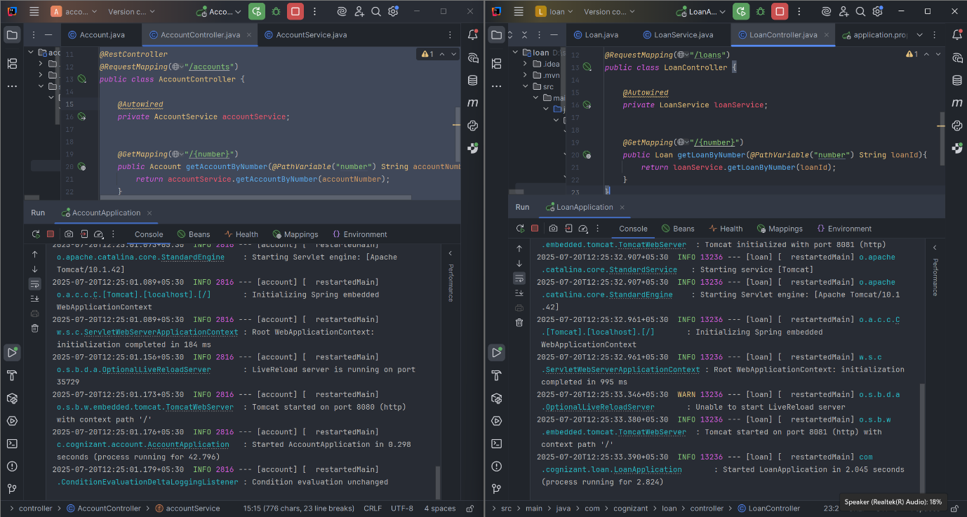

**BROWSER:**

